=================================LAMBDA LAB=========================================
create one lambda function to create a snapshot of running instance and Tag backup= Lambda.
- Create one lambda function
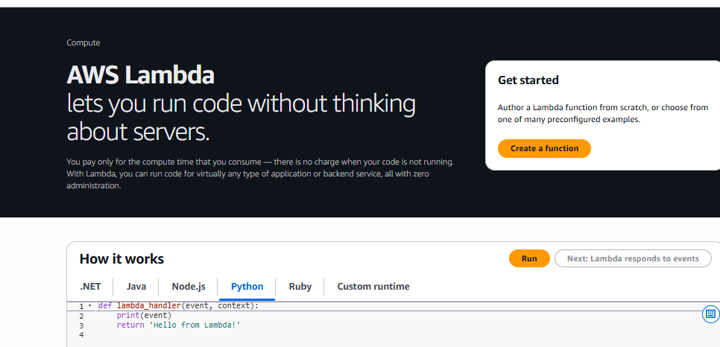
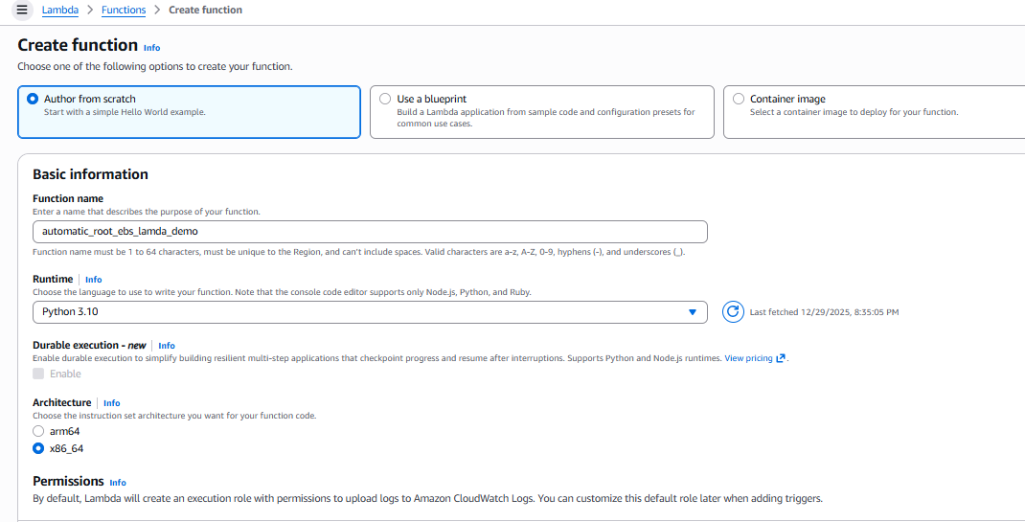
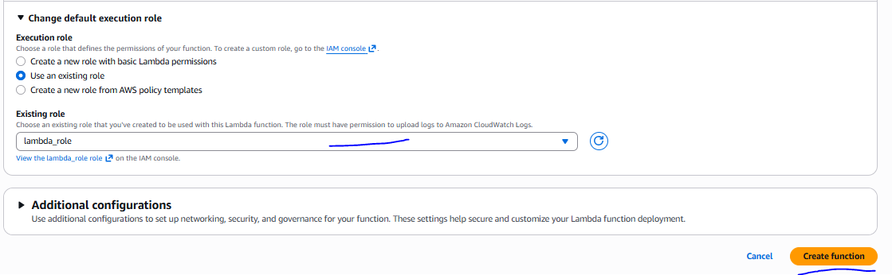
create role to assign lambda function
Function Has been created.
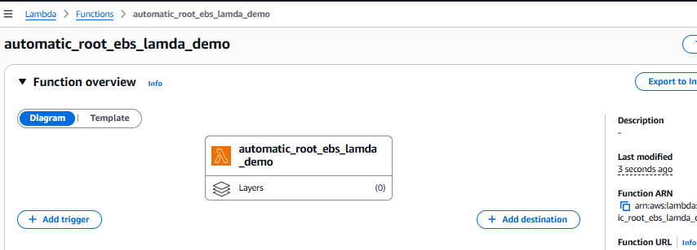
- Create two instance for creating a backup using lambda function of EBS root volume in different AZ.
two instance has been created with tag backup=Lambda and backup = no
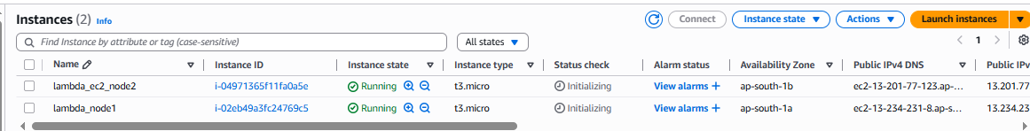

- Then apply one python script to create a snapshot of running instance and tag backup=Lambda
In Lambda function.
Python code is mention below
- Once code copy in the lambda_function.py need click on test button an create event (test01)
then save and invoke.
- Deploy the code and test as well as verify snapshot create or not
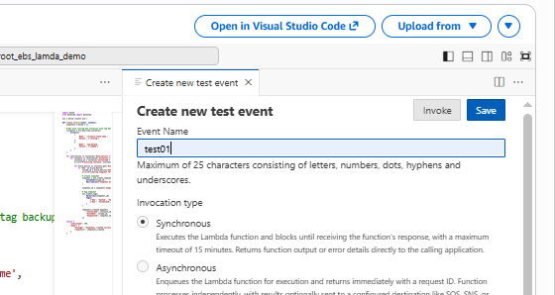
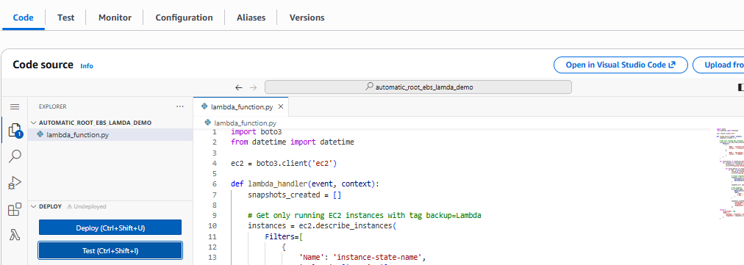
Snapshot has been created
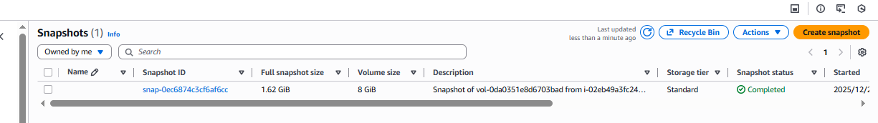
Once perform above step then schedule the function using cloud watch event service
Trigger Add Step

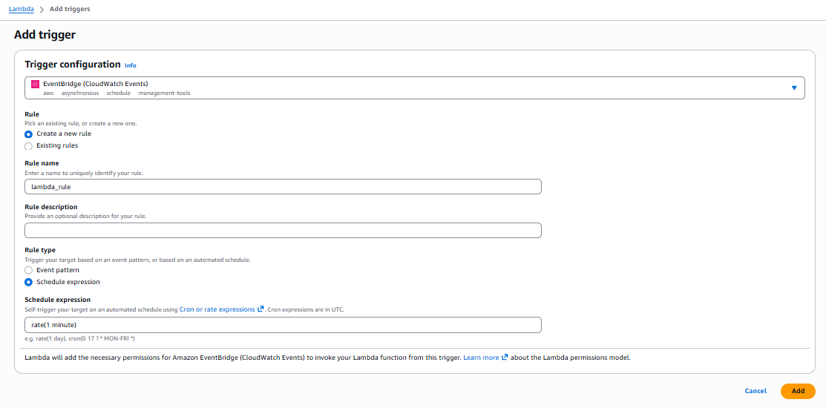
As per schedule snapshot has been created
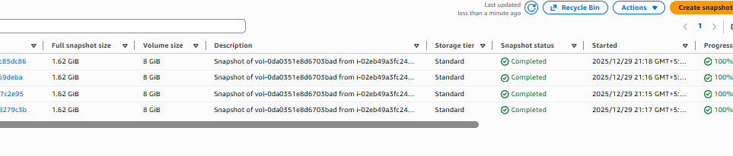

======code of take create a snapshot of running instance and tag backup=Lambda===============
import boto3
from datetime import datetime

ec2 = boto3.client('ec2')

def lambda_handler(event, context):
snapshots_created = []

# Get only running EC2 instances with tag backup=Lambda
instances = ec2.describe_instances(
Filters=[
{
'Name': 'instance-state-name',
'Values': ['running']
},
{
'Name': 'tag:backup',
'Values': ['Lambda']
}
]
)

for reservation in instances['Reservations']:
for instance in reservation['Instances']:
instance_id = instance['InstanceId']
print(f"Processing instance: {instance_id}")

for block_device in instance.get('BlockDeviceMappings', []):
if 'Ebs' in block_device:
volume_id = block_device['Ebs']['VolumeId']
print(f"Creating snapshot for volume {volume_id}")

# Create snapshot
snapshot = ec2.create_snapshot(
VolumeId=volume_id,
Description=f"Snapshot of {volume_id} from {instance_id}"
)

snapshot_id = snapshot['SnapshotId']

# Tag snapshot
ec2.create_tags(
Resources=[snapshot_id],
Tags=[
{'Key': 'backup', 'Value': 'Lambda'},
{'Key': 'InstanceId', 'Value': instance_id}
]
)

snapshots_created.append({
"InstanceId": instance_id,
"VolumeId": volume_id,
"SnapshotId": snapshot_id
})

return {
"statusCode": 200,
"body": {
"message": "Snapshots created successfully",
"snapshots": snapshots_created
}
}

